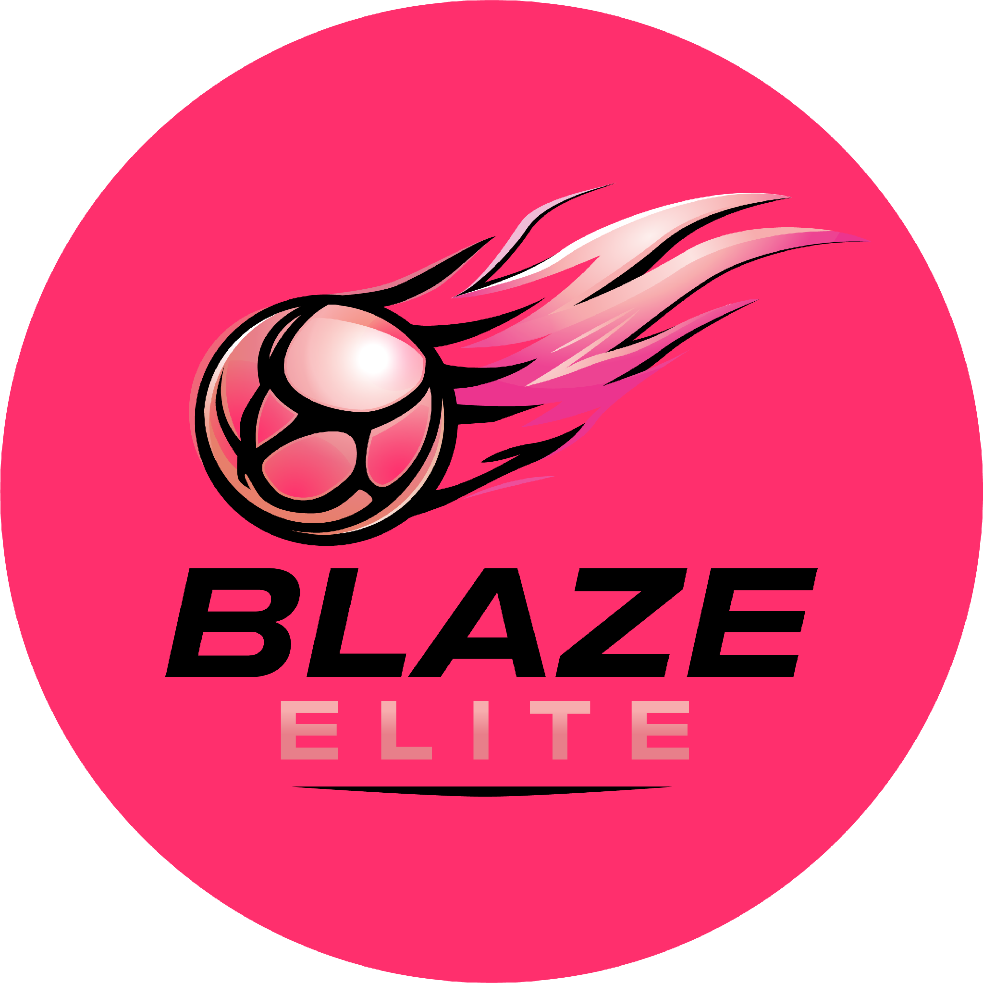

Athlete Code of Conduct
Blaze Elite Netball Club
Blaze Elite is a performance environment. Every athlete selected is here because we believe they have the potential, and the mindset, to contribute to a high-performing squad. This Code sets out what we expect in return.

1. Commitment & Attendance
- Maintain a minimum 90% attendance at squad training, strength & conditioning (where relevant) and fixtures, unless an absence is agreed in advance with the Head Coach.
- Prioritise Blaze Elite fixtures, tournaments and qualifying events.
- Promptly inform your Coach or Team Manager of any delay, absence, sickness or injury.
- If you know in advance you will be unavailable (for example, a school trip), inform your Coach and Team Manager as far ahead as possible.
- Know the date, time and venue of every training session and fixture.
- Arrive in plenty of time, and be proactive with your own warm-up on arrival.
- Bring your kit bag, water, snacks, towel and any medication you may need.
- Switch off mobile phones before the start of training sessions and matches.
Blaze Elite is not a recreational club. Consistency of commitment forms part of ongoing selection review, and athletes who do not attend training regularly may rule themselves out of selection.

2. Performance Standards & Presentation
- Train with intent and focus.
- Demonstrate coachability: listen to advice and respond to instruction.
- Accept performance-based decisions, including being substituted or not selected, respectfully and with grace.
- Maintain high standards of fitness, preparation and conduct.
- Wear appropriate kit and appearance for training and matches: Blaze Elite kit, suitable trainers, short nails, long hair tied back, and no jewellery.
- Know and play within the current England Netball Rules of Netball, in the spirit of the game.
Court time is earned. Selection is performance-based.

3. Team Culture
- Support team members positively, on and off the court.
- Treat teammates, coaches, umpires, other club members and opponents with respect.
- Ensure everyone is included, even if they are not your friend.
- Demonstrate resilience and professionalism.
- Represent Blaze Elite with pride, and never use bad language or insult opponents, coaches or spectators.
- Uphold Blaze Elite's standards on and off court.
Behaviour inconsistent with Blaze Elite's standards may result in a review of squad status.

4. Maintaining a Positive Environment
- Do not share negative commentary about coaching decisions, teammates or team selection in a way that creates a negative atmosphere at training, matches or tournaments.
- Raise any concerns about coaching or team matters directly and respectfully with the Head Coach, rather than discussing them with teammates in a way that undermines squad culture.

5. Social Media
- Do not post negative, disparaging or inflammatory comments about Blaze Elite, its coaches, teammates, opponents or officials, on social media, messaging groups, or any other public platform.
- Think before you post: content shared publicly reflects on you and on Blaze Elite.

6. Respect & Inclusion
- Treat coaches, teammates, opponents, officials and volunteers with respect, regardless of background.
- Discriminatory behaviour or language of any kind will not be tolerated.

7. Squad Integrity
- Understand that team selection, playing time and match-day squads are performance-based and at the Head Coach's discretion.
- Accept that being part of an assigned squad does not guarantee match-day selection or court time.
- Accept that you may occasionally be rotated between playing positions, or asked to play up an age group, for development purposes at the Head Coach's discretion.
- Accept that selection into Blaze Elite does not guarantee regional participation.
- Recognise that continued inclusion is subject to review, and that all athletes are required to re-trial at the end of each season.
- Disclose any injury, illness or fitness concern that could affect safe participation.
Blaze Elite maintains high standards to protect athlete development.

